|  |  |  |
| --- | --- | --- |
| **No.** | **action_name** | **Purpose** |
| 1 | jsp:forward | Forwards the request to an another resource (static / dynamic) |
| 2 | jsp:include | Includes another resource (static / dynamic) into JSP |
| 3 | jsp:param | Defines the parameter (Name Value String Pair) |
| 4 | jsp:useBean | Finds or instantiates a JavaBean |
| 5 | jsp:setProperty | Sets the property of a JavaBean |
| 6 | jsp:getProperty | Prints the property value of a JavaBean into output stream |
| 7 | jsp:plugin | Generates browser-specific code that makes an OBJECT or EMBED tag for the Java plugin |
| 8 | jsp:element | Defines XML elements dynamically |
| 9 | jsp:attribute | Defines dynamically defined XML element's attribute |
| 10 | jsp:body | Defines dynamically defined XML element's body |
| 11 | jsp:text | Use to write template text in JSP pages and documents |

* When the request get forwarded to a servlet from JSP, it will invoke the proper doXXX()in the servlet depending on the HTTP method in the request. If the proper doXXX() method does not exists, container sends the response which contains error message
* When we include the servlet in JSP, it will include the content of proper doXXX() method into JSP depending on the HTTP method in the request. If the proper doXXX() method does not exists in target servlet then container does not throw any Compile time / Runtime Exception. In this case it just ignores the include statement

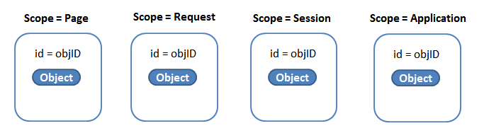

Translated Servlet Code:

com.jspiders.studentsapp.beans.Students students = **null**;

**synchronized** (session)

{

students

= (com.jspiders.studentsapp.beans.Students)

_jspx_page_context.getAttribute("students", PageContext.SESSION_SCOPE);

**if** (students == **null**)

{

students = **new** com.jspiders.studentsapp.beans.Students();

_jspx_page_context.setAttribute

("students", students, PageContext.SESSION_SCOPE);

}

}

**JSP Expression Language ???**

**How do I prevent the output of my JSP or Servlet pages from being cached by the browser?**

Ans) You will need to set the appropriate HTTP header attributes to prevent the dynamic content output by the JSP page from being cached by the browser. Just execute the following scriptlet at the beginning of your JSP pages to prevent them from being cached at the browser. You need both the statements to take care of some of the older browser versions.

<% response.setHeader("Cache-Control","no-store"); //HTTP 1.1

response.setHeader("Pragma\","no-cache"); //HTTP 1.0

response.setDateHeader ("Expires", 0); //prevents caching at the proxy server

%>

<http://docs.oracle.com/cd/A97336_01/buslog.102/a83726/genlovw3.htm>